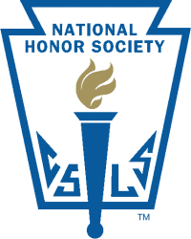
National Honor Society
Emma Showalter – President
Alyssa Oborny – Vice President
Marissa Wagner – Secretary/Treasurer

Members
Seniors Juniors
David Conner
Andrew Jay
Chase Klozenbucher
Alyssa Oborny
Brianna Reeves
Savannah Robinson
Sheldon Schmidt
Emma Showalter
Brooklyn Sherman
Marissa Wagner

The National Honor Society (NHS) is the nation's premier organization established to recognize outstanding high school students. More than just an honor roll, NHS serves to honor those students who have demonstrated excellence in the areas of scholarship, leadership, service, and character. These characteristics have been associated with membership in the organization since its beginning in 1921.

** The 2014-2015 induction ceremony will be October 15 at 8:30am in the LHS auditorium.
National Junior Honor Society

8th Grade Members

The National Junior Honor Society is the nation's premier organization established to recognize outstanding middle level students. More than just an honor roll, NJHS serves to honor those students who have demonstrated excellence in the areas of scholarship, leadership, service, citizenship and character. These characteristics have been associated with membership in the organization since its beginning in 1929.

** The 2014-2015 induction ceremony will be October 15 at 8:30am in the LHS auditorium.

